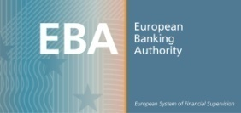
EBA Meeting Registration Form for:

Public hearing – Draft RTS on the concept of Gain on Sale associated with future margin income in a securitisation context
(CP-2012-07)
28 June 2012 – 10.00 to 11.30

taking place at: EBA Offices, 18th Floor, Tower 42, 25 Old Broad Street, London EC2N 1HQ
First name *
Surname *
Organisation *
Country
Email address
Tel number

* Please note that names of participants at this meeting may be made public
In order to make the necessary logistical arrangements and to allocate the available seats which are of a limited number, registration forms should be sent by 20 June 2012 at the latest to the following e-mail address: Katharina.Herzog@eba.europa.eu

It is essential that you return this email by the closing date so that your name is passed to Tower 42 Reception. Please do not book your flights and hotel until you have received confirmation of your registration. Confirmations of the registration will not be sent before the deadline for the registration.
For information, the following contact details can be used for the day of the meeting:
Tel: +44 (0)207 382 1770
Fax: +44 (0)207 382 1771

