Amended Mapping of Capital Intelligence Ratings credit assessments under the Standardised Approach

1. Executive summary
2. This report describes the mapping exercise carried out by the Joint Committee (JC) to propose an amended ‘mapping’[1] report of the credit assessments of Capital Intelligence Ratings (CI), with respect to the version published on 11 November 2015. The resulting mapping tables have remained unchanged with respect to the afore-mentioned version.
3. The methodology applied to produce the mapping is the one specified in the Commission Implementing Regulation (EU) 2016/1799 of 7 October 2016 (the Implementing Regulation) [2] laying down implementing technical standards with regard to the mapping of credit assessments of external credit assessment institutions for credit risk in accordance with Articles 136(1) and 136(3) of Regulation (EU) No 575/2013 of the European Parliament and of the Council (Capital Requirements Regulation – CRR). This Implementing Regulation employs a combination of the provisions laid down in Article 136(2) of the CRR.
4. The information base used to produce this mapping report reflects additional quantitative information collected after the submission of the draft Implementing Technical Standards by the JC to the European Commission. Regarding qualitative developments, the qualitative factors described in the Implementing Regulation remain unchanged while an additional credit rating scale has been incorporated, the Insurer Financial Strength Rating.
5. The mapping neither constitutes the one which ESMA shall report on in accordance with Article 21(4b) of Regulation (EC) No 1060/2009 (Credit Rating Agencies Regulation - CRA) with the objective of allowing investors to easily compare all credit ratings that exist with regard to a specific rated entity[3] nor should be understood as a comparison of the rating methodologies of CI with those of other ECAIs. This mapping should however be interpreted as the correspondence of the rating categories of CI with a regulatory scale which has been defined for prudential purposes.
6. As described in Recital 12 of the Implementing Regulation, it is necessary to avoid causing undue material disadvantage on those ECAIs which, due to their more recent entrance in the market, present limited quantitative information, with the view to balancing prudential with market concerns. Updates to the mapping should be made wherever this becomes necessary to reflect quantitative information collected after the entry into force of the Implementing Regulation
7. The resulting mapping tables have been specified in Annex III of the revised draft ITS on the mapping of ECAIs’ credit assessments under Article 136(1) and (3) of Regulation (EU) No 575/2013. Figure 1 below shows the result for the main ratings scale of CI, the International long-term issuer rating scale.

Figure 1: Mapping of CI’s International long-term issuer credit rating scale

|  |  |
| --- | --- |
| **Credit assessment** | **Credit quality step** |
| **AAA** | **1** |
| **AA** | **1** |
| **A** | **2** |
| **BBB** | **3** |
| **BB** | **4** |
| **B** | **5** |
| **C** | **6** |
| **RS** | **6** |
| **SD** | **6** |
| **D** | **6** |

1. Introduction
2. This report describes the mapping exercise carried out by the Joint Committee to propose an amended ‘mapping’ report of the credit assessments of Capital Intelligence Ratings (CI), with respect to the version published on 11 November 2015.
3. CI is a credit rating agency that has been registered with ESMA in 8 May 2012 and therefore meets the conditions to be an eligible credit assessment institution (ECAI)[4]. CI is a credit rating agency, headquartered in Cyprus, that provides credit analysis and independent rating opinions on financial institutions, corporates and governments located in Europe, the Middle East, Africa and Asia.
4. The methodology applied to produce the mapping is the one specified in the Implementing Regulation. This Implementing Regulation employs a combination of the provisions laid down in Article 136(2) of the CRR. The information base used to produce this mapping report reflects additional quantitative information collected after the submission of the draft Implementing Technical Standards by the JC to the European Commission. Regarding qualitative developments, the qualitative factors described in the Implementing Regulation remain unchanged while an additional credit rating scale has been incorporated, the Insurer Financial Strength Rating. The quantitative information is drawn from data available in the ESMA’s central repository (CEREP[5]) based on the credit rating information submitted by the ECAIs as part of their reporting obligations.
5. The following sections describe the rationale underlying the mapping exercise carried out by the Joint Committee (JC). Section 3 describes the relevant ratings scales of CI’s for the purpose of the mapping. Section 4 contains the methodology applied to derive the mapping of CI’s main rating scale whereas Sections 5 and 6 refer to the mapping of its remaining relevant ratings scales. The mapping tables are shown in Appendix 4 of this document and have been specified in Annex III of the revised draft ITS on the mapping of ECAIs’ credit assessments under Article 136(1) and (3) of Regulation (EU) No 575/2013.
6. CI credit ratings and rating scales
7. CI produces a variety of credit ratings. Column 2 of Figure 2 in Appendix 1 shows the relevant credit ratings that may be used by institutions for the calculation of risk weights under the Standardised Approach (SA)[6]:

* **Long-term issuer ratings,** defined as a summary of an entity’s overall creditworthiness and its ability and willingness to meet its financial obligations as they come due. Ratings assigned to an entity are comparable across international borders. Long-term issuer ratings assess the time period of more than year.
* **Long-term issue ratings,** defined as an opinion of an entity’s ability and willingness to honour its financial obligations with respect to a specific bond or other debt instrument. A long-term issue rating is assigned to debt instruments with an original maturity of more than one year.
* **Long-term insurer financial strength ratings,** defined as a forward-looking opinion of an insurer’s capacity and willingness to pay its valid insurance contract obligations when they become due using a globally applicable rating scale. An IFSR is not specific for any particular policy or product, nor does it address non-policy obligations. IFSRs may be expressed in terms of foreign currency and/or local currency.
* **Short-term issuer ratings,** defined as long-term issuer ratings, with the only difference that short-term issuer ratings assess the time periods of up to one year.
* **Short-term issue ratings,** defined as long-term issue ratings, with the only difference that a short-term issue rating is assigned to debt instruments with an original maturity of up to one year.
* **Short-term insurer financial strength ratings,** defined as the long-term insurer financial strength ratings described above, with the only difference being that it refers to an insurer’s contractual obligations with durations of up to one year.

1. CI assigns these credit ratings to different rating scales as illustrated in column 3 of Figure 2 in Appendix 1. Therefore, a specific mapping has been prepared for the following rating scales:

* **International long-term issuer rating scale.** The specification of this rating scale is described in Figure 3 of Appendix 1.
* **International long-term issue rating scale.** The specification of this rating scale is described in Figure 4 of Appendix 1.
* **International long-term insurer financial strength rating scale.** The specification of this rating scale is described in Figure 5 of Appendix 1.
* **International short-term issuer rating scale.** The specification of this rating scale is described in Figure 6 of Appendix 1.
* **International short-term issue rating scale.** The specification of this rating scale is described in Figure 7 of Appendix 1.
* **International short-term insurer financial strength rating scale.** The specification of this rating scale is described in Figure 8 of Appendix 1.

1. The mapping of the International long-term issuer rating scale is explained in Section 4 and it has been derived in accordance with the quantitative factors, qualitative factors and benchmarks specified in the Implementing Regulation.
2. The mapping of the International short-term issuer rating scale is explained in Section 5 and it has been indirectly derived from the mapping of the International long-term issuer ratings scale and the internal relationship established by CI between these two scales, as specified in Article 13 of the Implementing Regulation. This internal relationship is shown in Figure 9 of Appendix 1.
3. The indirect mapping approach described in the previous paragraph has also been applied In the case of the other rating scales, as explained in Section 6. In these cases, however, the relationship with the long-term issuer rating scale (or short-term issuer rating scale) has been assessed, for the purpose of the mapping, by the JC based on the comparison of the meaning and relative position of the rating categories.
4. Mapping of CI’s International long-term issuer rating scale
5. The mapping of the International long-term issuer rating scale has consisted of two differentiated stages where the quantitative and qualitative factors as well as the benchmarks specified in Article 136(2) CRR have been taken into account.
6. In the first stage, the quantitative factors referred to in Article 1 of the Implementing Regulation have been taken into account to differentiate between the levels of risk of each rating category:

* The long run default rate of a rating category has been used to arrive at an initial mapping proposal by comparing its value with the benchmark specified in point (a) of Article 14 of the Implementing Regulation.
* The short run default rates of a rating category have been compared with the benchmarks specified in point (b) of Article 14 of the Implementing Regulation, which represent the maximum expected deviation of a default rate from its long-term value within a CQS.

1. In a second stage, the qualitative factors proposed in Article 7 of the Implementing Regulation have been considered to challenge the result of the previous stage, especially in those ratings categories where less default data has been available.
   1. Initial mapping based on the quantitative factors
2. This mapping report reflects additional quantitative information collected after the submission of the draft ITS by the JC to the Commission.
   * 1. Calculation of the short-run and long-run default rates
3. The short run and long run default rates of each rating category have been calculated with the pools of items rated from 1 January 2001 to 1 July 2015, based on the information contained in CEREP and according to the provisions laid down in the Implementing Regulation. As in the original mapping report:

* For rating categories AAA, AA, A and C the number of credit ratings cannot be considered to be sufficient for the calculation of the short and long run default rates specified in the Articles 3 – 5 of the Implementing Regulation since the number of rated items is below the required minimum. As a result, the allocation of the CQS for these rating categories has been made in accordance with Article 6 of the Implementing Regulation, as shown in Figure 16 of Appendix 3. In these cases, the long run default rate benchmark associated with the equivalent category in the international rating scale is a key qualitative factor that has been used for the mapping proposal.
* For RS, SD and D rating categories, no calculation of default rates has been made since they already reflect a ‘default’ situation. This is in line with the original mapping report.
* For rating categories BBB, BB and B the number of credit ratings can be considered to be sufficient and therefore the calculation has followed the rules established in Articles 3 to 5 of the Implementing Regulation[7]. The result of the calculation of the short run and long run default rates for each rating category is shown in Figure 12 of Appendix 3.

1. Withdrawn ratings have been weighted by 50% as indicated in Article 4(3) of the Implementing Regulation.
2. The default definition applied by CI, described in Appendix 2, has been used for the calculation of default rates.
   * 1. Mapping proposal based on the long run default rate
3. Rating categories BBB, BB and B are initially allocated to CQS 3 based on the comparison of its long run default rate (see Figure 12 in Appendix 3) and the long run default rate benchmark intervals established in point (a) of Article 14 of the Implementing Regulation, as illustrated in the second column of Figure 17 in Appendix 4.
4. For rating categories AAA, AA, A, and C the comparison has been made according to Article 6 of the Implementing Regulation. Therefore, the numbers of defaulted and non-defaulted rated items have been used together with the prior expectation of the equivalent rating category of the international rating scale. The results are shown in Figure 15 of Appendix 3.
5. The number of rated items in each of these categories is equal or larger than the respective minimum required number of observed items given the number of defaulted items in the rating category. This holds regardless of the data cohort chosen. Thus the credit quality steps associated with the AAA/AA, A and C rating categories in the international rating scale (CQS 1, CQS 2 and CQS 6 respectively) can be assigned.
   * 1. Reviewed mapping based on the short run default rates
6. As shown in Figures 13 to 15 in Appendix 3, the short run default rates of rating categories BBB, BB and B have been compared with the short run default rate benchmark values established in point (b) of Article 14 of the Implementing Regulation[8].
7. The objective is to assess whether the short-run default rates have deviated from their corresponding benchmark values and whether any observed deviation has been caused by a weakening of the assessment standards. Therefore short run default rates experienced within a rating category have been confronted with the short run benchmarks “monitoring” and “trigger” levels specified in Annex I of the Implementing Regulation: to perform this analysis confidence intervals for the short run default rates have been calculated.
8. The result of this comparison can be found in the third column of Figure 17 in Appendix 4:

* BBB: the additional short-run default rates collected after the draft ITS was produced do not breach neither the monitoring nor the trigger benchmark of CQS3. Therefore the initial mapping based on the long run default rate remains confirmed at this stage.
* BB: the additional short-run default rates collected after the draft ITS was produced breach the trigger benchmark associated with CQS3 in two observations (2012H2 and 2013H1). The qualitative factors acquire more importance for this category.
* B: the additional short-run default rates available after the mapping was produced breach the trigger level associated with CQS3 for two consecutive years. This suggests that the underlying long-run default rate is representative of a less favourable credit quality step than CQS 3.
  1. Final mapping after review of the qualitative factors

1. The qualitative factors specified in Article 7 of the Implementing Regulation have been used to challenge the mapping proposed by the default rate calculation. Qualitative factors acquire more importance in the rating categories where quantitative evidence is not sufficient to test the default behavior[9], or where quantitative evidence is sufficient but does not reflect the expected risk profile underlying a rating category.
2. Capital Intelligence has not registered any change in the quantitative factors since the draft Implementing Technical Standards submitted by the JC to the Commission. Therefore the qualitative considerations remain unchanged with respect to the original mapping report, which means that the meaning and relative position of the credit assessments is the only qualitative factor that suggests an adjustment of the mapping proposal resulting from the quantitative factors. In particular, the meaning and relative position of rating categories BB and B are in line with CQS 4 and CQS 5, respectively. In the case of RS, SD and D rating categories, their meaning is consistent with the one of CQS 6 stated in Annex II of the Implementing Regulation.
3. Mapping of CI’s Short-Term issuer rating scale
4. CI also produces short-term issuer ratings and assigns them to the international short-term issuer rating scale (see Figure 6 in Appendix 1). Given that the default information referred to these rating categories cannot be comparable with the 3-year time horizon that characterizes the benchmarks established in the Implementing Regulation, the internal relationship established by CI between these two rating scales (described in Figure 9 of Appendix 1) has been used to derive the mapping of the Short-term issuer rating scale. This should ensure the consistency of the mappings proposed for CI.
5. More specifically, as each short-term issuer rating can be associated with a range of long-term issuer ratings, the CQS assigned to the short-term rating category has been determined based on the most frequent CQS assigned to the related long-term rating categories. In case of draw, the most conservative CQS has been considered. If the most frequent step is identified as CQS 5 or 6, CQS 4 is allocated, as the risk weights assigned to CQS 4 to 6 are all equal to 150% according to Article 131 CRR.
6. As the internal relationship remains unchanged with respect to the original mapping, the results remain the same and are shown on Figure 18 of Appendix 4.
7. Mapping of other CI credit rating scales
8. As mentioned in Section 3, CI produces a number of additional credit ratings that are assigned to different credit rating scales.
9. Based on the methodology described in the previous section, the mapping of each rating scale has been derived from the relationship established by the JC with the relevant Long-term or Short-term issuer ratings scale. Specifically, as each rating can be associated with one or a range of long-term (or short-term) rating categories, its CQS has been determined based on the most frequent CQS assigned to the related rating categories. In case of draw, the most conservative CQS has been considered. Results are shown in Figures 19 to 21 of Appendix 4:

* **International long-term issue rating scale** (see Figure 4 in Appendix 1). The rating categories can be considered comparable to those of the Long-term issuer ratings scale. Therefore the mapping of each rating category has been derived from its meaning and relative position and the mapping of the corresponding categories of the Long-term issuer rating scale. The result of the mapping of this scale is shown in Figure 19 of Appendix 4.
* **International short-term issue rating scale** (see Figure 7 in Appendix 1). The rating categories can be considered comparable to those of the Short-term issuer ratings scale. Therefore the mapping of each rating category has been derived by the JC from its meaning and relative position and the mapping of the corresponding categories of the Short-term issuer rating scale. The result of the mapping of this scale is shown in Figure 20 of Appendix 4.
* **International long-term insurer financial strength ratings** (see Figure 5 in Appendix 1).The rating categories can be considered comparable to those of the Long-term issuer credit rating scale. Even though the definitions of the rating categories refer to insurance companies, the mapping was derived from the meaning and relative position of the rating categories and the mapping of the corresponding categories of the Long-term issuer rating scale. The result of the mapping of this scale is shown in Figure 21 of Appendix 4.
* **International short-term insurer financial strength ratings** (see Figure 8 in Appendix 1).The rating categories can be considered comparable to those of the Short-term issuer credit rating scale. Even though the definitions of the rating categories refer to insurance companies, the mapping was derived from the meaning and relative position of the rating categories and the mapping of the corresponding categories of the Long-term issuer rating scale. The result of the mapping of this scale is shown in Figure 22 of Appendix 4.

Appendix 1: Credit ratings and rating scales

Figure 2: CI’s relevant credit ratings and rating scales

|  |  |  |
| --- | --- | --- |
| SA exposure classes | Name of credit rating | Credit rating scale |
| **Long-term ratings** |  |  |
| Central governments/ Central banks | Long-term issuer rating | International long-term issuer rating scale |
|  | Long-term issue rating | International long-term issue rating scale |
| Regional governments/local authorities | Long-term issuer rating | International long-term issuer rating scale |
|  | Long-term issue rating | International long-term issue rating scale |
| Institutions | Long-term issuer rating | International long-term issuer rating scale |
|  | Long-term issue rating | International long-term issue rating scale |
| Corporates | Long-term issuer rating | International long-term issuer rating scale |
|  | Long-term issue rating | International long-term issue rating scale |
|  | Long-term insurer financial strength ratings | International long-term insurer financial strength rating scale |
| **Short-term ratings** |  |  |
| Central governments/ Central banks | Short-term issuer rating | International short-term issuer rating scale |
|  | Short-term issuer rating | International short-term issuer rating scale |
| Regional governments/local authorities | Short-term issuer rating | International short-term issuer rating scale |
|  | Short-term issuer rating | International short-term issuer rating scale |
| Institutions | Short-term issuer rating | International short-term issuer rating scale |
|  | Short-term issue rating | International short-term issue rating scale |
| Corporates | Short-term issuer rating | International short-term issuer rating scale |
|  | Short-term issue rating | International short-term issue rating scale |
|  | Short-term insurer financial strength ratings | International short-term insurer financial strength rating scale |

Source: CI

Figure 3: International long-term issuer rating scale

|  |  |
| --- | --- |
| Credit assessment | Meaning of the credit assessment |
| AAA | The highest credit quality. Exceptional capacity for timely fulfilment of financial obligations and most unlikely to be affected by any foreseeable adversity. Extremely strong financial condition and very positive non-financial factors. |
| AA | Very high credit quality. Very strong capacity for timely fulfilment of financial obligations. Unlikely to have repayment problems over the long term and unquestioned over the short and medium terms. Adverse changes in business, economic and financial conditions are unlikely to affect the institution significantly. |
| A | High credit quality. Strong capacity for timely fulfilment of financial obligations. Possesses many favourable credit characteristics but may be slightly vulnerable to adverse changes in business, economic and financial conditions. |
| BBB | Good credit quality. Satisfactory capacity for timely fulfilment of financial obligations. Acceptable credit characteristics but some vulnerability to adverse changes in business, economic and financial conditions. Medium grade credit characteristics and the lowest investment grade category. |
| BB | Speculative credit quality. Capacity for timely fulfilment of financial obligations is vulnerable to adverse changes in internal or external circumstances. Financial and/or non-financial factors do not provide significant safeguard and the possibility of investment risk may develop. |
| B | Significant credit risk. Capacity for timely fulfilment of financial obligations is very vulnerable to adverse changes in internal or external circumstances. Financial and/or non-financial factors provide weak protection; high probability for investment risk exists. |
| C | Substantial credit risk is apparent and the likelihood of default is high. Considerable uncertainty as to the timely repayment of financial obligations. Credit is of poor standing with financial and/or non-financial factors providing little protection. |
| RS | Regulatory supervision (this rating is assigned to financial institutions only). The obligor is under the regulatory supervision of the authorities due to its weak financial condition. The likelihood of default is extremely high without continued external support. |
| SD | Selective default. The obligor has failed to service one or more financial obligations but CI believes that the default will be restricted in scope and that the obligor will continue honouring other financial commitments in a timely manner. |
| D | The obligor has defaulted on all, or nearly all, of its financial obligations. |

Source: CI

Figure 4: International long-term issue rating scale

|  |  |
| --- | --- |
| Credit assessment | Meaning of the credit assessment |
| AAA | Bonds and financial obligations that are rated AAA are considered to be of the highest quality. They carry the smallest degree of investment risk. Interest payments are protected by a significant and exceptionally stable margin, and principal is extremely secure. There are unlikely to be significant changes in the various protective elements. In any case, such possible changes are very unlikely to weaken the fundamentally strong position of such issues. |
| AA | Bonds and financial obligations that are rated AA are considered to be of very high quality by all criteria. These are high-grade instruments, but are rated lower than AAA instruments as the elements of protection may not be as large and there may be slightly greater fluctuation within the margin of protection. The overall risk is slightly greater than for AAA obligations. |
| A | Bonds and financial obligations that are rated A exhibit many positive investment characteristics and are classed as upper- to medium-grade investment quality. Various factors giving protection to principal and interest are considered very sound, but certain components may be evident which indicate future potential impairment. |
| BBB | Bonds and financial obligations that are rated BBB are regarded as medium-grade. These securities are neither highly nor lowly protected. Both interest payments and principal security are currently adequate but certain protective elements may be missing or may be slightly more unreliable over the longer-term. Obligations rated BBB do not display very strong investment characteristics. The obligations form the lowest investment grade level and some may possibly possess speculative characteristics. |
| BB | Bonds and financial obligations that are rated BB are below investment grade and possess speculative characteristics. There is some uncertainty in the longer-term future of these instruments. The protection of interest and principal is likely to be very moderate and thereby not well cushioned during both favourable and unfavourable conditions in the future. |
| B | Bonds and financial obligations that are rated B generally do not possess attractive investment characteristics. The certainty of interest and principal payments, or of maintenance of other terms of the contract, over the long term, is limited. |
| CCC | Bonds and financial obligations that are rated CCC are of poor standing. Such issues are vulnerable to default, with significant uncertainty with respect to the payment of principal or interest. |
| CC | Bonds and financial obligations that are rated CC are highly speculative. Such issues are highly vulnerable to default or have other substantial weaknesses. |
| C | Bonds and financial obligations that are rated C are of low class. Such issues are regarded as possessing extremely poor prospects and are extremely vulnerable to non-payment. |
| D | The issue is in payment default. Interest or principal payments are not made on the due date. |

Source: CI

Figure 5: International long-term insurer financial strength rating scale

|  |  |
| --- | --- |
| Credit assessment | Meaning of the credit assessment |
| AAA | The highest credit quality. Exceptional capacity for fulfilment of insurance obligations and most unlikely to be affected by any foreseeable adversity. Extremely strong financial condition and very positive non-financial factors. |
| AA | Very high financial strength. Very strong capacity for fulfilment of insurance obligations. Unlikely to have payment problems over the long term and unquestioned over the short and medium term. Adverse changes in business, economic and financial conditions are unlikely to affect the entity significantly. |
| A | High financial strength. Strong capacity for fulfilment of insurance obligations. Possesses many favourable financial security characteristics but may be slightly vulnerable to adverse changes in business, economic and financial conditions. |
| BBB | Good financial strength. Satisfactory capacity for fulfilment of insurance obligations. Acceptable financial security characteristics but some vulnerability to adverse changes in business, economic and financial conditions. Medium grade credit characteristics and the lowest investment grade category. |
| BB | Speculative grade financial strength. Capacity for fulfilment of insurance obligations is vulnerable to adverse changes in internal or external circumstances. Financial and/or non-financial factors do not provide significant safeguard and the possibility of investment risk may develop. |
| B | Significant risk to financial strength. Capacity for fulfilment of insurance obligations is very vulnerable to adverse changes in internal or external circumstances. Financial and/or non-financial factors provide weak protection; high probability for investment risk exists. |
| C | Substantial risk to financial strength is apparent and the likelihood of default is high. Considerable uncertainty as to the payment of insurance obligations. Financial strength is of poor standing with financial and/or non-financial factors providing little protection. |
| RS | Regulatory supervision. The insurer is under the regulatory supervision of the authorities due to its weak financial condition. The likelihood of default is extremely high without continued external support. |
| SD | Selective default. The insurer has failed to service one or more class of insurance obligations, but CI believes that the default will be restricted in scope and that the insurer will continue honouring other obligations. |
| D | The insurer has defaulted on all, or nearly all, of its insurance obligations. A ‘D’ would also be assigned upon filing for bankruptcy or similar protection. |

Source: CI

Figure 6: International short-term issuer rating scale

|  |  |
| --- | --- |
| **Credit assessment** | **Meaning of the credit assessment** |
| A1 | Superior credit quality. Highest capacity for timely repayment of short-term financial obligations that is extremely unlikely to be affected by unexpected adversities. Institutions with a particularly strong credit profile have a “+” affixed to the rating. |
| A2 | Very strong capacity for timely repayment but may be affected slightly by unexpected adversities. |
| A3 | Strong capacity for timely repayment that may be affected by unexpected adversities. |
| B | Adequate capacity for timely repayment that could be seriously affected by unexpected adversities. |
| C | Inadequate capacity for timely repayment if unexpected adversities are encountered in the short term. |
| RS | Regulatory supervision (this rating is assigned to financial institutions only). The obligor is under the regulatory supervision of the authorities due to its weak financial condition. The likelihood of default is extremely high without continued external support. |
| SD | Selective default. The obligor has failed to service one or more financial obligations but CI believes that the default will be restricted in scope and that the obligor will continue honouring other financial commitments in a timely manner. |
| D | The obligor has defaulted on all, or nearly all, of its financial obligations |

Source: CI

Figure 7: International short-term issue rating scale

|  |  |
| --- | --- |
| **Credit assessment** | **Meaning of the credit assessment** |
| A1 | The highest short-term rating assigned. Issues are considered to have the highest capacity for timely repayment of short-term financial obligations. The issues in this category exhibit extremely strong protection factors. Interest payments and principal are safeguarded by a wide margin. Issues with a particularly strong profile have a "+" affixed to the rating. |
| A2 | The capacity for timely repayment of interest and principal is high. The issue and/or the issuer possess highly favourable characteristics and protection factors are good. |
| A3 | Satisfactory capacity for repayment of interest and principal. However, issues in this category are more vulnerable to adverse changes in business, economic and financial conditions. Protection factors are adequate but not as strong or certain as obligations in the higher short-term rating classifications. |
| B | Speculative capacity for timely repayment of interest and principal. The timely repayment of obligations is vulnerable to adverse changes, and protection factors are not high. |
| C | Doubtful capacity for timely repayment of interest and principal. Default risk is high. |
| D | The issue is in payment default. Interest or principal payments are not made on the due date. |

Source: CI

Figure 8: International short-term insurer financial strength rating scale

|  |  |
| --- | --- |
| **Credit assessment** | **Meaning of the credit assessment** |
| A1 | Superior financial strength. Highest capacity for the payment of short-term insurance obligations that is extremely unlikely to be affected by unexpected adversities. Institutions with a particularly strong credit profile have a “+” affixed to the rating. |
| A2 | Very strong capacity for payment of insurance obligations but may be affected slightly by unexpected adversities. |
| A3 | Strong capacity for payment of insurance obligations but may be affected by unexpected adversities. |
| B | Adequate capacity for payment of insurance obligations that could be seriously affected by unexpected adversities. |
| C | Inadequate capacity for payment of insurance obligations if unexpected adversities are encountered in the short term. |
| RS | Regulatory supervision. The insurer is under the regulatory supervision of the authorities due to its weak financial condition. The likelihood of default is extremely high without continued external support. |
| SD | Selective default. The insurer has failed to service one or more class of insurance obligations, but CI believes that the default will be restricted in scope and that the insurer will continue honouring other obligations. |
| D | The insurer has defaulted on all, or nearly all, of its insurance obligations. A ‘D’ would also be assigned upon filing for bankruptcy or similar protection. |

Source: CI

Figure 9: Internal relationship between CI’s long-term and short-term issuer rating scales

|  |  |  |  |  |  |  |  |
| --- | --- | --- | --- | --- | --- | --- | --- |
| **Long-term issuer rating scale** | **Short-term issuer rating scale** | | | | | | |
| AAA | A-1+ |  |  |  |  |  |  |
| AA+ |  |  |  |  |  |  |
| AA |  |  |  |  |  |  |
| AA- | A-1 |  |  |  |  |  |
| A+ |  |  |  |  |  |  |
| A |  |  |  |  |  |  |
| A- |  | A-2 |  |  |  |  |
| BBB+ |  |  |  |  |  |  |
| BBB |  |  | A-3 |  |  |  |
| BBB- |  |  |  |  |  |  |
| BB+ |  |  |  |  | B |  |  |
| BB |  |  |  |  |  |  |
| BB- |  |  |  |  |  |  |
| B+ |  |  |  |  |  |  |
| B |  |  |  |  |  |  |
| B- |  |  |  |  |  |  |
| C |  |  |  |  |  | C |  |
| D |  |  |  |  |  |  | D |

Source: CI

Appendix 2: Definition of default

Capital Intelligence considers a default to have occurred when:

1. An issuer or obligor fails to pay a material sum of principal and/or interest on a financial obligation in accordance with its terms;
2. An issuer files for bankruptcy or similar protection from creditors – unless there is reason to believe that debt service payments will continue to be made in a timely manner;
3. An issuer restructures, reschedules, exchanges or in some other way renegotiates a debt instrument and the following apply:
   1. There is an adverse change to the terms of the original debt agreement; and
   2. The renegotiation or exchange is considered by Capital Intelligence to be distressed or coercive.

Adverse changes to the terms of the original debt agreement may include the following:

* A reduction in the principal amount or coupon/ interest rate;
* An extension of the maturity date or loan tenor;
* A reduction in seniority or a substantial weakening of covenants;
* A cash tender for less than par;
* A decrease in the frequency of payments (e.g. to bullet from amortising);
* Swapping debt for equity or hybrid instruments.

A debt renegotiation or exchange is deemed to be distressed or coercive when one or more of the following apply:

* The issuer would, in CI’s opinion, be unable to honour its obligations under the original debt agreement due to its weak financial position;
* The issuer is unwilling to honour its obligations to those investors who choose not to participate in the renegotiations or exchange offer;
* The issuer threatens, explicitly or implicitly, to miss payments, weaken the governing indenture or to seek bankruptcy should the terms of its proposal or exchange offer not be accepted.

Source: CI

Appendix 3: Default rates of each rating category

Figure 10: Number of rated items, with relevant weights[10]

|  |  |  |  |  |  |  |  |
| --- | --- | --- | --- | --- | --- | --- | --- |
| **Date** | **AAA** | **AA** | **A** | **BBB** | **BB** | **B** | **C** |
| 01/01/2001 | 0.0 | 1.0 | 36.5 | 112.0 | 140.5 | 32.5 | 15.5 |
| 01/07/2001 | 0.0 | 2.0 | 35.5 | 115.0 | 129.5 | 38.5 | 20.5 |
| 01/01/2002 | 0.0 | 2.0 | 35.5 | 114.5 | 112.0 | 49.5 | 19.0 |
| 01/07/2002 | 0.0 | 2.0 | 36.0 | 117.5 | 96.5 | 55.0 | 19.5 |
| 01/01/2003 | 0.0 | 2.0 | 38.5 | 112.5 | 86.0 | 60.5 | 14.0 |
| 01/07/2003 | 0.0 | 2.0 | 39.5 | 118.0 | 80.5 | 58.5 | 14.0 |
| 01/01/2004 | 0.0 | 2.0 | 39.5 | 113.0 | 80.5 | 59.0 | 13.0 |
| 01/07/2004 | 0.0 | 2.0 | 43.5 | 114.5 | 82.0 | 62.0 | 2.0 |
| 01/01/2005 | 0.0 | 2.0 | 45.5 | 115.5 | 74.5 | 58.5 | 2.0 |
| 01/07/2005 | 0.0 | 3.0 | 47.0 | 115.5 | 76.0 | 57.0 | 1.0 |
| 01/01/2006 | 0.0 | 3.0 | 51.5 | 106.5 | 93.5 | 39.5 | 1.0 |
| 01/07/2006 | 0.0 | 3.0 | 54.5 | 104.5 | 92.0 | 36.5 | 2.0 |
| 01/01/2007 | 0.0 | 3.0 | 64.5 | 97.5 | 87.0 | 37.5 | 1.0 |
| 01/07/2007 | 0.0 | 4.0 | 66.5 | 113.0 | 67.5 | 36.5 | 1.0 |
| 01/01/2008 | 0.0 | 9.0 | 66.0 | 110.5 | 63.0 | 37.5 | 0.0 |
| 01/07/2008 | 0.0 | 10.0 | 70.0 | 110.5 | 71.0 | 28.5 | 0.0 |
| 01/01/2009 | 0.0 | 13.0 | 68.0 | 109.0 | 69.0 | 28.5 | 0.0 |
| 01/07/2009 | 0.0 | 13.0 | 67.5 | 105.5 | 66.0 | 27.0 | 0.0 |
| 01/01/2010 | 0.0 | 12.0 | 64.5 | 107.0 | 63.5 | 28.0 | 0.0 |
| 01/07/2010 | 0.0 | 12.0 | 54.5 | 116.5 | 64.0 | 27.0 | 0.0 |
| 01/01/2011 | 0.0 | 13.0 | 52.5 | 110.0 | 76.0 | 28.0 | 0.0 |
| 01/07/2011 | 0.0 | 13.0 | 50.5 | 108.0 | 77.0 | 31.5 | 0.0 |
| 01/01/2012 | 0.0 | 12.0 | 51.0 | 104.5 | 77.5 | 30.5 | 0.0 |
| 01/07/2012 | 0.0 | 12.0 | 51.0 | 103.5 | 78.5 | 32.0 | 0.0 |
| 01/01/2013 | 0.0 | 12.0 | 52.0 | 93.0 | 87.0 | 29.5 | 0.0 |

Source: Joint Committee calculations based on CEREP data

Figure 11: Number of defaulted rated items

|  |  |  |  |  |  |  |  |
| --- | --- | --- | --- | --- | --- | --- | --- |
| **Date** | **AAA** | **AA** | **A** | **BBB** | **BB** | **B** | **C** |
| 01/01/2001 | 0 | 0 | 0 | 2 | 0 | 0 | 0 |
| 01/07/2001 | 0 | 0 | 0 | 1 | 1 | 0 | 0 |
| 01/01/2002 | 0 | 0 | 0 | 1 | 1 | 0 | 0 |
| 01/07/2002 | 0 | 0 | 0 | 0 | 1 | 1 | 0 |
| 01/01/2003 | 0 | 0 | 0 | 0 | 0 | 0 | 1 |
| 01/07/2003 | 0 | 0 | 0 | 0 | 0 | 0 | 0 |
| 01/01/2004 | 0 | 0 | 0 | 0 | 0 | 0 | 0 |
| 01/07/2004 | 0 | 0 | 0 | 1 | 0 | 0 | 0 |
| 01/01/2005 | 0 | 0 | 0 | 1 | 0 | 0 | 0 |
| 01/07/2005 | 0 | 0 | 0 | 1 | 0 | 0 | 0 |
| 01/01/2006 | 0 | 0 | 0 | 0 | 1 | 0 | 0 |
| 01/07/2006 | 0 | 0 | 0 | 2 | 0 | 0 | 1 |
| 01/01/2007 | 0 | 0 | 0 | 2 | 0 | 0 | 0 |
| 01/07/2007 | 0 | 0 | 0 | 2 | 0 | 0 | 0 |
| 01/01/2008 | 0 | 0 | 0 | 3 | 0 | 0 | 0 |
| 01/07/2008 | 0 | 0 | 0 | 3 | 0 | 0 | 0 |
| 01/01/2009 | 0 | 0 | 0 | 2 | 1 | 0 | 0 |
| 01/07/2009 | 0 | 0 | 0 | 0 | 0 | 0 | 0 |
| 01/01/2010 | 0 | 0 | 0 | 1 | 0 | 0 | 0 |
| 01/07/2010 | 0 | 0 | 1 | 3 | 0 | 0 | 0 |
| 01/01/2011 | 0 | 0 | 1 | 2 | 1 | 0 | 0 |
| 01/07/2011 | 0 | 0 | 1 | 2 | 0 | 1 | 0 |
| 01/01/2012 | 0 | 0 | 0 | 2 | 1 | 1 | 0 |
| 01/07/2012 | 0 | 0 | 0 | 2 | 4 | 3 | 0 |
| 01/01/2013 | 0 | 0 | 0 | 0 | 5 | 3 | 0 |

Source: Joint Committee calculations based on CEREP data

Figure 12: Short-run and long-run observed default rates , in per cent

|  |  |  |  |  |  |  |  |
| --- | --- | --- | --- | --- | --- | --- | --- |
| **Date** | **AAA** | **AA** | **A** | **BBB** | **BB** | **B** | **C** |
| 01/01/2001 | n.a. | n.a. | n.a. | 1.79 | 0.00 | 0.00 | n.a. |
| 01/07/2001 | n.a. | n.a. | n.a. | 0.87 | 0.77 | 0.00 | n.a. |
| 01/01/2002 | n.a. | n.a. | n.a. | 0.87 | 0.89 | 0.00 | n.a. |
| 01/07/2002 | n.a. | n.a. | n.a. | 0.00 | 1.04 | 1.82 | n.a. |
| 01/01/2003 | n.a. | n.a. | n.a. | 0.00 | 0.00 | 0.00 | n.a. |
| 01/07/2003 | n.a. | n.a. | n.a. | 0.00 | 0.00 | 0.00 | n.a. |
| 01/01/2004 | n.a. | n.a. | n.a. | 0.00 | 0.00 | 0.00 | n.a. |
| 01/07/2004 | n.a. | n.a. | n.a. | 0.87 | 0.00 | 0.00 | n.a. |
| 01/01/2005 | n.a. | n.a. | n.a. | 0.87 | 0.00 | 0.00 | n.a. |
| 01/07/2005 | n.a. | n.a. | n.a. | 0.87 | 0.00 | 0.00 | n.a. |
| 01/01/2006 | n.a. | n.a. | n.a. | 0.00 | 1.07 | 0.00 | n.a. |
| 01/07/2006 | n.a. | n.a. | n.a. | 1.91 | 0.00 | 0.00 | n.a. |
| 01/01/2007 | n.a. | n.a. | n.a. | 2.05 | 0.00 | 0.00 | n.a. |
| 01/07/2007 | n.a. | n.a. | n.a. | 1.77 | 0.00 | 0.00 | n.a. |
| 01/01/2008 | n.a. | n.a. | n.a. | 2.71 | 0.00 | 0.00 | n.a. |
| 01/07/2008 | n.a. | n.a. | n.a. | 2.71 | 0.00 | 0.00 | n.a. |
| 01/01/2009 | n.a. | n.a. | n.a. | 1.83 | 1.45 | 0.00 | n.a. |
| 01/07/2009 | n.a. | n.a. | n.a. | 0.00 | 0.00 | 0.00 | n.a. |
| 01/01/2010 | n.a. | n.a. | n.a. | 0.93 | 0.00 | 0.00 | n.a. |
| 01/07/2010 | n.a. | n.a. | n.a. | 2.58 | 0.00 | 0.00 | n.a. |
| 01/01/2011 | n.a. | n.a. | n.a. | 1.82 | 1.32 | 0.00 | n.a. |
| 01/07/2011 | n.a. | n.a. | n.a. | 1.85 | 0.00 | 3.17 | n.a. |
| 01/01/2012 | n.a. | n.a. | n.a. | 1.91 | 1.29 | 3.28 | n.a. |
| 01/07/2012 | n.a. | n.a. | n.a. | 1.93 | 5.10 | 9.38 | n.a. |
| 01/01/2013 | n.a. | n.a. | n.a. | 0.00 | 5.75 | 10.17 | n.a. |
| **Weighted Average** | n.a. | n.a. | n.a. | 1.20 | 0.77 | 0.89 | n.a. |

Source: Joint Committee calculations based on CEREP data

Figure 13: Short-run and long-run observed default rates of BBB rating category, with short-run benchmarks associated with CQS3

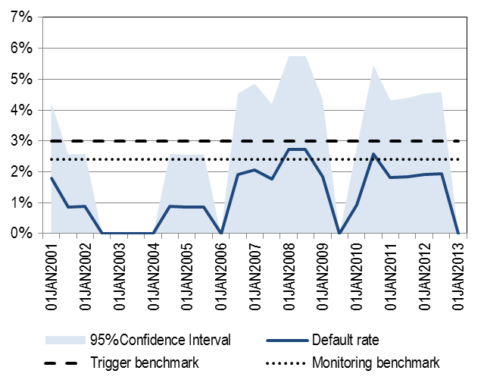

Source: Joint Committee calculations based on CEREP data.

Figure 14: Short-run and long-run observed default rates of BB rating category

Panel A: Short-run benchmarks associated with CQS3

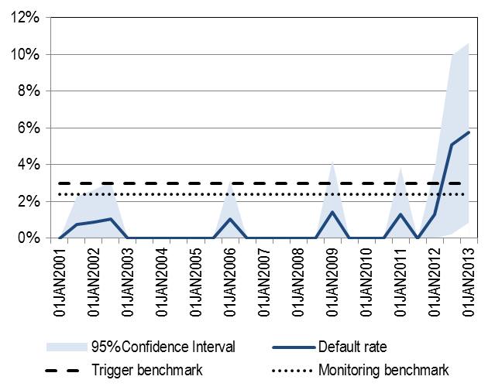

Panel B: Short-run benchmarks associated with CQS4

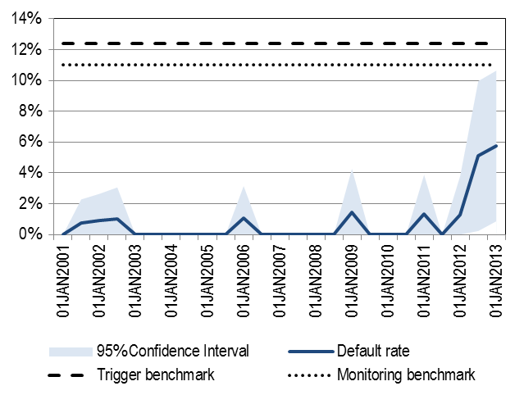

Figure 15: Short-run and long-run observed default rates of B rating category

Panel A: Short-run benchmarks associated with CQS3

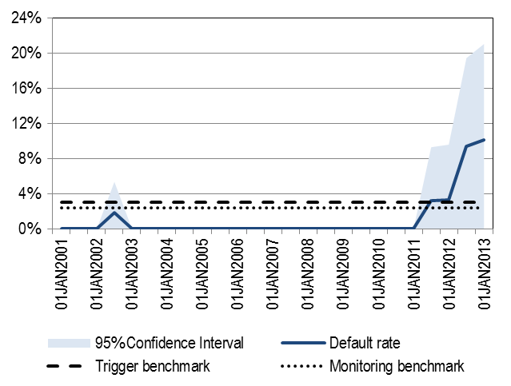

Source: Joint Committee calculations based on CEREP data.

Panel B: Short-run benchmarks associated with CQS4

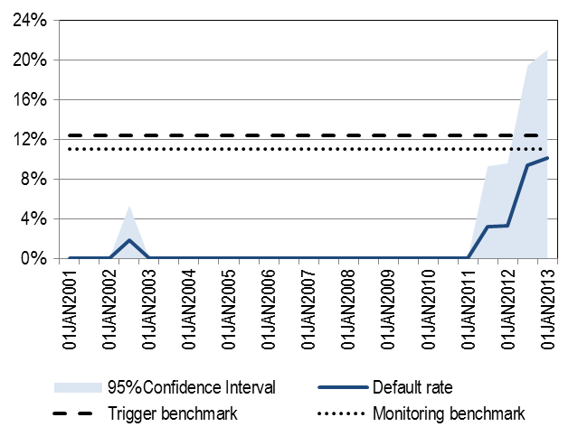

Panel C: Short-run benchmarks associated with CQS5

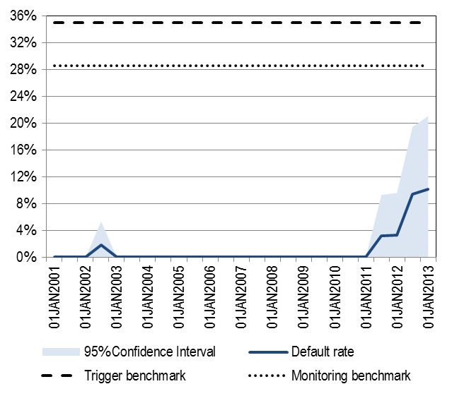

Source: Joint Committee calculations based on CEREP data.

Figure 16: Mapping proposal for rating categories with a non-sufficient number of credit ratings

|  |  |  |  |
| --- | --- | --- | --- |
| **2001-2005** | **AAA/AA** | **A** | **C** |
| CQS of equivalent international rating category | CQS 1 | CQS 2 | CQS 6 |
| N. observed defaulted items | 0 | 0 | 1 |
| Minimum N. rated items | 0 | 0 | n.a. |
| Observed N. rated items | 20.0 | 397.0 | 120.5 |
| **Mapping proposal** | **CQS 1** | **CQS 2** | **CQS 6** |

|  |  |  |  |
| --- | --- | --- | --- |
| **2006-2010** | **AAA/AA** | **A** | **C** |
| CQS of equivalent international rating category | CQS 1 | CQS 2 | CQS 6 |
| N. observed defaulted items | 0 | 1 | 1 |
| Minimum N. rated items | 0 | 0 | n.a. |
| Observed N. rated items | 82.0 | 627.5 | 5 |
| **Mapping proposal** | **CQS 1** | **CQS 2** | **CQS 6** |

|  |  |  |  |
| --- | --- | --- | --- |
| **2011-2013** | **AAA/AA** | **A** | **C** |
| CQS of equivalent international rating category | CQS 1 | CQS 2 | CQS 6 |
| N. observed defaulted items | 0 | 2 | 0 |
| Minimum N. rated items | 0 | 167 | n.a. |
| Observed N. rated items | 62 | 257 | 0 |
| **Mapping proposal** | **CQS 1** | **CQS 2** | **CQS 6** |

Appendix 4: Mappings of each rating scale

Figure 17: Mapping of CI’s International long-term issuer rating scale

|  |  |  |  |  |
| --- | --- | --- | --- | --- |
| **Credit assessment** | **Initial mapping *based on LR DR***  **(CQS)** | **Review *based on SR DR***  **(CQS)** | **Final review *based on qualitative factors***  **(CQS)** | **Main reason for the mapping** |
| **AAA** | 1 | n.a. | **1** | The quantitative factors are representative of the final CQS. |
| **AA** | 1 | n.a. | **1** |
| **A** | 2 | n.a. | **2** | The quantitative factors are representative of the final CQS. |
| **BBB** | 3 | 3 | **3** | The quantitative factors are representative of the final CQS. |
| **BB** | 3 | 3/4 | **4** | The meaning and relative position of the rating category is representative of the final CQS. |
| **B** | 3 | 4 | **5** | The meaning and relative position of the rating category is representative of the final CQS. |
| **C** | 6 | n.a. | **6** | The quantitative factors are representative of the final CQS. |
| **RS** | n.a. | n.a. | **6** | The meaning and relative position of the rating category is representative of the final CQS. |
| **SD** | n.a. | n.a. | **6** | The meaning and relative position of the rating category is representative of the final CQS. |
| **D** | n.a. | n.a. | **6** | The meaning and relative position of the rating category is representative of the final CQS. |

Figure 18: Mapping of CI’s International short-term issuer rating scale

|  |  |  |  |  |
| --- | --- | --- | --- | --- |
| **Credit assessment** | **Corresponding Long-term issuer rating scale assessment (established by CI)** | **Range of CQS of corresponding Long-term issuer rating scale** | **Final review *based on qualitative factors***  **(CQS)** | **Main reason for the mapping** |
| **A1+** | AAA/AA- | 1 | 1 | The final CQS has been determined based on the most frequent step associated with the corresponding long-term credit rating category. |
| **A1** | AA-/A- | 2 | 2 |
| **A2** | A-/BBB | 2 - 3 | 3 |
| **A3** | BBB/BBB- | 3 | 3 |
| **B** | BB+/B- | 4 - 5 | 4 | The final CQS has been determined based on the range of steps associated with the corresponding long-term credit rating category. The risk weights assigned to CQS 4 to 6 are all 150%, therefore CQS 4. |
| **C** | C | 6 | 4 |
| **RS** | RS | 6 | 4 |
| **SD** | SD | 6 | 4 |
| **D** | D | 6 | 4 |

Figure 19: Mapping of CI’s International long-term issue rating scale

|  |  |  |  |  |
| --- | --- | --- | --- | --- |
| **Credit assessment** | **Corresponding Long-term issuer rating scale assessment (assessed by JC)** | **Range of CQS of corresponding Long-term issuer ratings scale** | **Final review *based on qualitative factors* (CQS)** | **Main reason for the mapping** |
| **AAA** | AAA | 1 | **1** | The final CQS has been determined based on the most frequent step associated with the corresponding long-term issuer rating category. |
| **AA** | AA | 1 | **1** |
| **A** | A | 2 | **2** |
| **BBB** | BBB | 3 | **3** |
| **BB** | BB | 4 | **4** |
| **B** | B | 5 | **5** |
| **CCC** | CCC | 6 | **6** |
| **CC** | CC | 6 | **6** |
| **C** | C | 6 | **6** |
| **D** | D | 6 | **6** |

Figure 20: Mapping of CI’s International Short-term issue rating scale

|  |  |  |  |  |
| --- | --- | --- | --- | --- |
| **Credit assessment** | **Corresponding Short-term issuer rating scale assessment (assessed by JC)** | **Range of CQS of corresponding Short-term issuer rating scale** | **Final review *based on qualitative factors* (CQS)** | **Main reason for the mapping** |
| **A1+** | A1+ | 1 | **1** | The final CQS has been determined based on the most frequent step associated with the corresponding short-term issuer rating category. |
| **A1** | A1 | 2 | **2** |
| **A2** | A2 | 3 | **3** |
| **A3** | A3 | 3 | **3** |
| **B** | B | 4 | **4** |
| **C** | C | 4 | **4** |
| **D** | D | 4 | **4** |

Figure 21: Mapping of CI’s international long-term insurer financial strength ratings

|  |  |  |  |  |
| --- | --- | --- | --- | --- |
| **Credit assessment** | **Corresponding Long-term issuer rating scale assessment (assessed by JC)** | **Range of CQS of corresponding Long-term issuer ratings scale** | **Final review *based on qualitative factors* (CQS)** | **Main reason for the mapping** |
| **AAA** | AAA | 1 | **1** | The final CQS has been determined based on the most frequent step associated with the corresponding long-term issuer rating category. |
| **AA** | AA | 1 | **1** |
| **A** | A | 2 | **2** |
| **BBB** | BBB | 3 | **3** |
| **BB** | BB | 4 | **4** |
| **B** | B | 5 | **5** |
| **C** | C | 6 | **6** |
| **RS** | RS | 6 | **6** |
| **SD** | SD | 6 | **6** |
| **D** | D | 6 | **6** |

Figure 22: Mapping of CI’s International short-term insurer financial strength ratings

|  |  |  |  |  |
| --- | --- | --- | --- | --- |
| **Credit assessment** | **Corresponding short-term issuer rating scale assessment (assessed by JC)** | **Range of CQS of corresponding Short-term issuer rating scale** | **Final review *based on qualitative factors* (CQS)** | **Main reason for the mapping** |
| **A1+** | A1+ | 1 | **1** | The final CQS has been determined based on the most frequent step associated with the corresponding short-term issuer rating category. |
| **A1** | A1 | 2 | **2** |
| **A2** | A2 | 3 | **3** |
| **A3** | A3 | 3 | **3** |
| **B** | B | 4 | **4** |
| **C** | C | 4 | **4** |
| **RS** | RS | 4 | **4** |
| **SD** | SD | 4 | **4** |
| **D** | D | 4 | **4** |

1. According to Article 136(1), the ‘mapping’ is the correspondence between the credit assessments of and ECAI and the credit quality steps set out in Regulation (EU) No 575/2013 (Capital Requirements Regulation – CRR).
2. OJ L 275, 12.10.2016, p. 3-18
3. In this regard please <https://www.esma.europa.eu/sites/default/files/library/esma_2015-1473_report_on_the_possibility_of_establishing_one_or_more_mapping.pdf>.
4. It is important to note that the mapping does not contain any assessment of the registration process of CI carried out by ESMA.
5. <https://cerep.esma.europa.eu/cerep-web/>
6. As explained in recital 4 ITS, Article 4(1) CRA allows the use of the credit assessments for the determination of the risk-weighted exposure amounts as specified in Article 113(1) CRR as long as they meet the definition of credit rating in Article 3(1)(a) CRA.
7. In the case of categories BB and B, the perceived risk profile considered to assess the sufficiency of ratings is given by the long run benchmark underlying their homonymous categories in the international rating scale, i.e. 7.50% and 20.00% respectively.
8. For all other rating categories except BBB, BB and B, the number of credit ratings cannot be considered to be sufficient and therefore no calculation of the short run default rate has been made. In the case of rating categories CCC to C, the review of the short run default rates is not necessary since they have been mapped to CQS6.
9. The default behavior of a rating category is considered to be properly tested if the quantitative factors for that rating category are calculated under Articles 3 – 5 of the Implementing Regulation.
10. Withdrawn ratings have been weighted by 50% as indicated in Article 4(3) of the ITS.